Q 1) Select best choice. [20]

- form of access is used to add and remove nodes from a queue.
  - LIFO, Last In First Out
  - FIFO, First In First Out
  - Both a and b
  - None of these

- Which of the following is an application of stack?
  - finding factorial
  - Parenthesis matching
  - infix to postfix conversion
  - all of the above

- Which of the following points is not true about Linked List data structure when it is compared with array.

  - It is easy to insert and delete elements in Linked List
  - Random access is not allowed in a typical implementation of Linked Lists
  - Link lists have better cache locality (as compared to arrays) that can make them better in terms of performance.
  - The size of array has to be pre-decided, linked lists can change their size any time.

- You are given pointers to first and last nodes of a singly linked list, which of the following operations are dependent on the length of the linked list?
  - Insert a new element as a first element
  - Delete the first element
  - Delete the last element of the list
  - Add a new element at the end of the list

- How many stacks are needed to implement a queue. Consider the situation where no other data structure like arrays, linked list is available to you.
  - 1
  - 2
  - 3
  - 4
- Let A be a square matrix of size n x n. Consider the following program. What is the expected output?
C = 100
for (i=1; i<=n; i++)
for (j=1; j<=n; j++)
{
Temp = A[i][j] + C
A[i][j] = A[j][i]
A[j][i] = Temp – C }
for (i=1; i<=n; i++)
for (j=1; j<=n; j++)
Output(A[i][j]);

  - The matrix A itself
  - Transpose of matrix A
  - Adding 100 to the upper diagonal elements and subtracting 100 from diagonal elements of A
  - None

- In a k-dimensional array, every element of array is:
  - K dimensional
  - k-1 dimensional
  - 2k dimensional
  - K+1 dimensional

- Consider following matrix:

1 0 9 8 3
4 5 6 7 8
2 3 4 5 6

Column major representation of this matrix will be:
  - 1 0 9 8 3 4 5 6 7 8 2 3 4 5 6
  - 1 0 4 5 2 3 9 8 6 7 4 5 3 8 6
  - 1 4 2 0 5 3 9 6 4 8 7 5 3 8 6
  - 5 3 8 6 6 4 8 7 1 4 2 0 5 3 9

- Assume a right-Lower sparse matrix is stored in row-major order. If a 2D index of an element of this sparse matrix is given by (x, y), what will be the linear (1D) formula to access this element.
  - x(x-1)/2 + (y-1)
  - x(x-1)/2 + (r-y)
  - x(x+1)/2 + (c-1)
  - none of above

- A single array A[1..MAXSIZE] is used to implement two stacks. The two stacks grow from opposite ends of the array. Variables top1 and top2 (topl< top 2) point to the location of the topmost element in each of the stacks. If the space is to be used efficiently, the condition for “stack full” is:
  - (top1 = MAXSIZE/2) and (top2 = MAXSIZE/2+1)
  - top1 + top2 = MAXSIZE
  - (top1= MAXSIZE/2) or (top2 = MAXSIZE)
  - d. top1= top2 -1

Q 2) [4+6]
2-a. Convert this expression into postfix form.

( ( H * ( ( ( ( A + ( ( B + C ) * D ) ) * F ) * G ) * E ) ) + J ) ;

2-b. Write code to convert an infix expression to postfix expression. Assume that you already have a function named prec() to get precedence of an operator.

Q 3) Read carefully the given code and answer. [3+2]

Q 3-a. The following function reverse() is supposed to reverse a singly linked list. There is one line missing at the end of the function, write that line.
/* Link list node */
class node
{
public:
int data;
node* next;
};
/* head_ref is a double pointer which points to head (or start) pointer of linked list */
static void reverse(struct node** head_ref)
{
struct node* prev = NULL;
struct node* current = *head_ref;
struct node* next;
while (current != NULL)
{
next = current->next;
current->next = prev;
prev = current;
current = next; }
/*ADD A STATEMENT HERE*/
}
Answer:

Q 3-b. The following C function takes a single-linked list of integers as a parameter and rearranges the elements of the list. The function is called with the list containing the integers 1, 2, 3, 4, 5, 6, 7 in the given order. What will be the contents of the list after the function completes execution?
struct node
{
int value;
struct node *next;
};
void rearrange(node *list)
{
node *p, * q;
int temp;
if ((!list) || !list->next)
return;
p = list;
q = list->next;
while(q)
{
temp = p->value;
p->value = q->value;
q->value = temp;
p = q->next;
q = p ? p->next : 0;
}
}

Answer:

Q 4-a. Derive formula to access (i,j)th element of Upper-right sparse matrix stored in column major order. [5+5]

4-b. Decimal numbers like 16461 are “symmetrical”. Other examples include 22,55, 141, 12421, 65456 etc. These numbers are also called palindromic numbers. Input a number and check using stack that whether the number is palindromic or not.

Q 5-a. Given a doubly linked list and a key x. The problem is to delete all occurrences of the given key x from the doubly linked list. Write delete function to accomplish this task. [8+7]

Example:
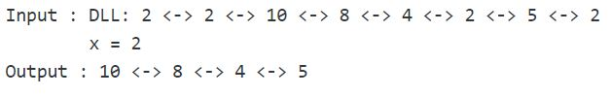

Q 5-b. Split a circular single linked list (not circular queue) into two halves making two new lists. In case of odd number of elements, first half will contain the extra element.

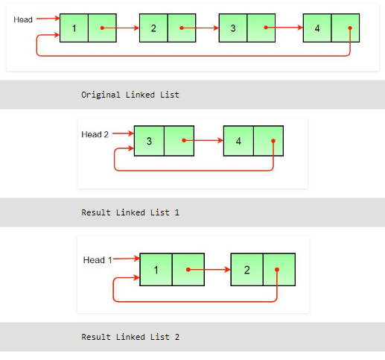

Q 6) Write code to insert a node in priority queue, where priority is based on data item named ‘Imp’ and largest number has highest priority. Assume that queue is implemented as circular double linked list and always has more than two members. [10]

